**Ideation Phase**

**Empathize & Discover**

|  |  |
| --- | --- |
| Date | 10 October 2022 |
| Team ID | PNT2022TMID33276 |
| Project Name | Machine Learning-Based Predictive Analysis for Aircraft Engine |
| Maximum Marks | 4 Marks |

**Empathy Map Canvas:**

**MACHINE LEARNING-BASED PREDICTIVE ANALYSIS FOR AIRCRAFT ENGINE**

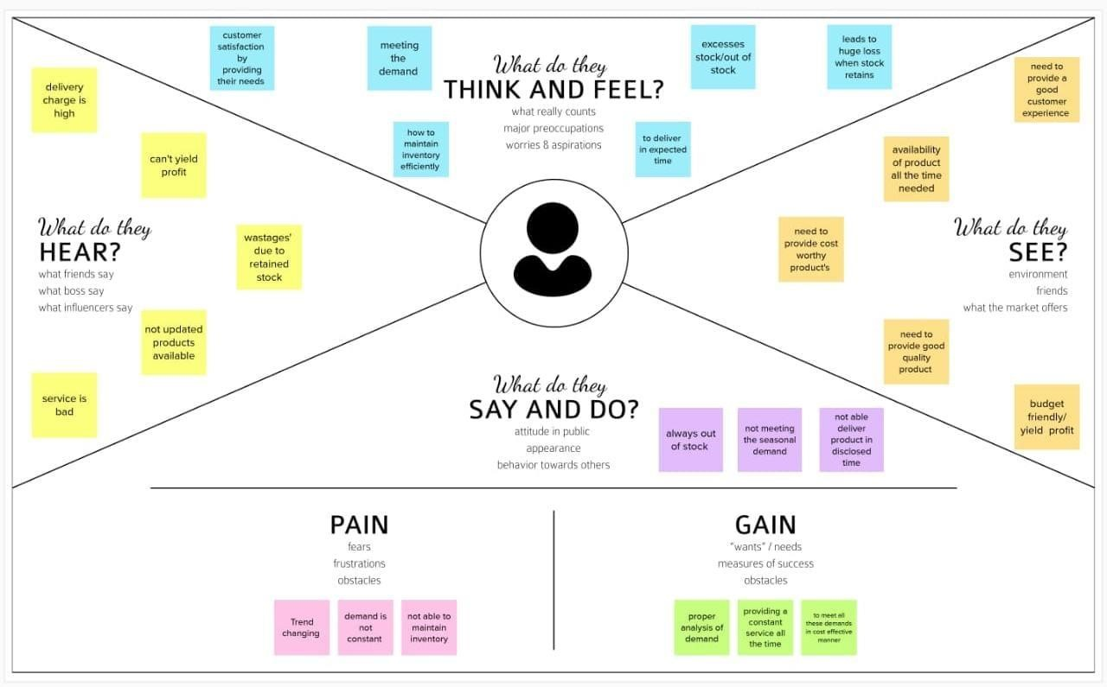

Reference: [https://app.mural.co/invitation/mural/snscollegeofengineering7699/1663394581805?sender=u3bc3 bbda3caba543358b3117&key=d9ad55d1-5b00-445b-8cf4-e1861e64e618](https://app.mural.co/invitation/mural/snscollegeofengineering7699/1663394581805?sender=u3bc3bbda3caba543358b3117&key=d9ad55d1-5b00-445b-8cf4-e1861e64e618)